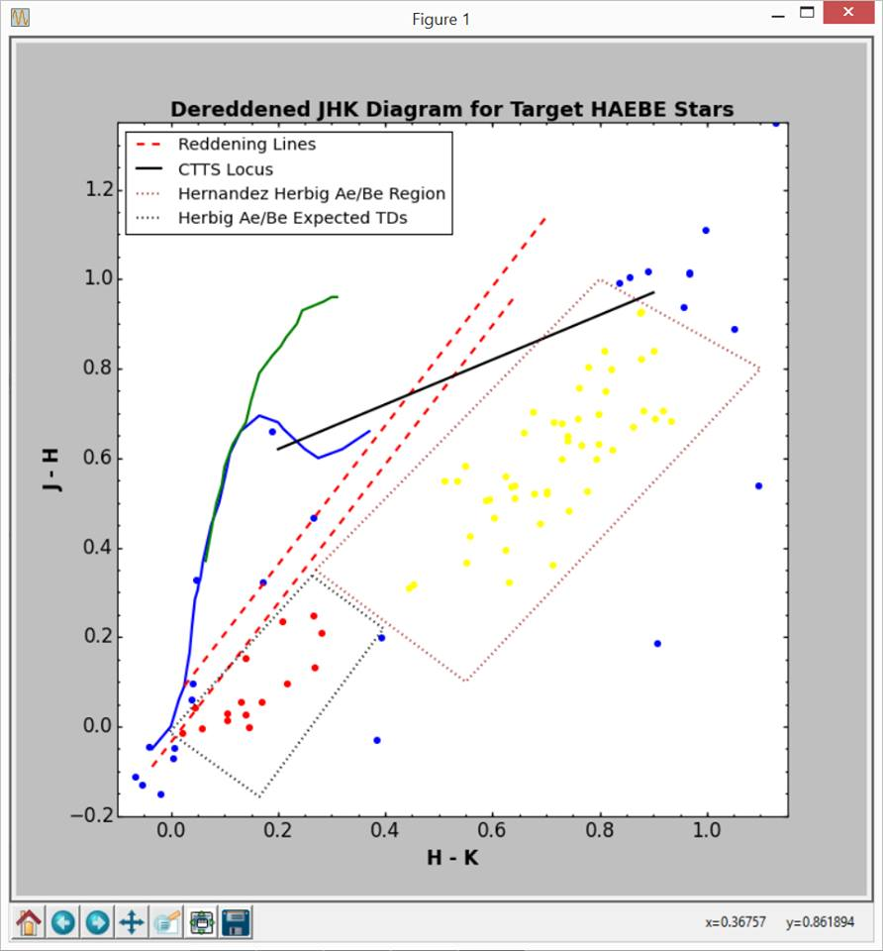 (with flags checked)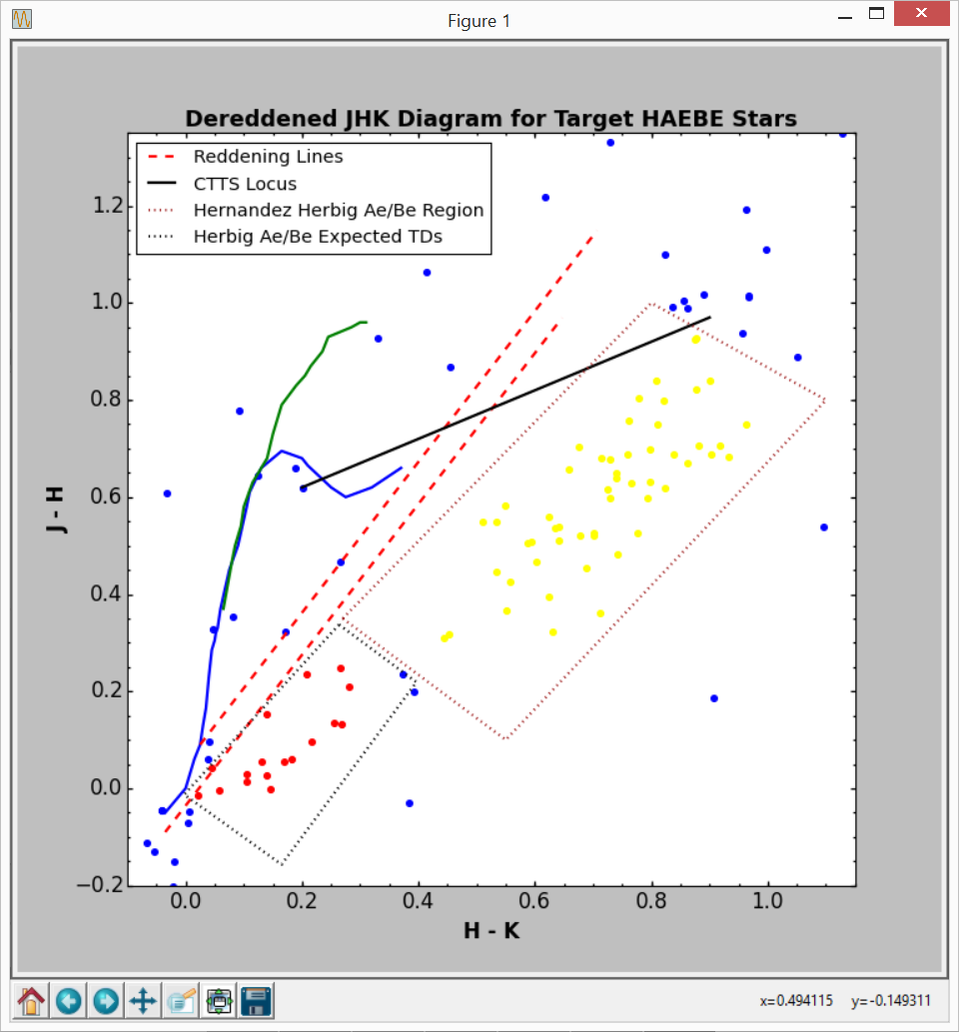 (without flags checked)

a 0 0.808754438749 0.837882929627

a 1 0.511621947647 0.54804897651

c 2 nan nan

b 3 0.268846591274 0.130596356692

a 4 0.919506872965 0.705746215846

c 5 nan nan

c 6 nan nan

b 7 0.132432040124 0.053563830936

a 8 0.642641038086 0.508599298844

a 9 0.659754422627 0.656882904577

c 10 -0.039625303744 -0.046087248793

c 11 0.265886897607 0.466716832645

a 12 0.810923436711 0.747798397535

c 13 0.0053356530128 -0.0724619606083

c 14 -0.053379730402 -0.130970159633

a 15 0.625998366289 0.558980932746

a 16 0.74143381894 0.647583123642

a 17 0.689318897423 0.452280600956

a 18 0.878841302224 0.925001362133

a 19 0.863923477018 0.66979846016

a 20 0.779808442643 0.801495762123

c 21 0.797337923371 nan

b 22 0.218217672497 0.095933243219

c 23 nan nan

b 24 0.140902502966 0.151228682294

c 25 -0.304159066254 -0.44047028476

b 26 0.106637754541 0.027561139285

c 27 0.039336338028 0.059811830986

c 28 nan nan

c 29 nan nan

b 30 0.1471414758 -0.001995062397

a 31 0.535371267606 0.5478743662

a 32 0.675449674201 0.701095361569

c 33 -0.134210744532 -0.122054710513

c 34 nan nan

c 35 nan nan

c 36 nan nan

b 37 0.046261352021 0.040629208099

b 38 0.140714366197 0.024762816902

c 39 1.40458204438 1.79692912681

a 40 0.4529059558 0.317548461905

a 41 0.553075026314 0.364182685513

c 42 nan nan

a 43 0.603203919478 0.464977990593

a 44 0.882754470995 0.704882979728

a 45 0.589374639826 0.504912663531

b 46 0.266862728684 0.248109033

c 47 nan -0.20213925513

a 48 0.743827774922 0.48004646021

c 49 0.190487879263 0.659196043813

b 50 0.104993295867 0.01292346796

c 51 nan 0.777312963884

c 52 nan nan

c 53 nan nan

a 54 0.901223179206 0.837528575955

c 55 -0.066318704229 -0.11247864788

c 56 0.837647949928 0.9894778065

a 57 0.55066743662 0.58076428169

c 58 0.393109810787 0.197244995272

c 59 nan 0.837163493007

c 60 1.90830282971 1.69703249574

c 61 0.855827516959 1.00304605941

c 62 0.766716177258 nan

c 63 0.96827340845 1.01256529577

c 64 0.956814153743 0.936826949618

c 65 1.47234809646 1.97494580277

c 66 0.172318929669 0.322280651056

c 67 0.384106374079 -0.02979340227

a 68 0.6241880884 0.393465790242

c 69 nan nan

a 70 0.875412998054 0.923013583752

c 71 0.0066218509102 -0.049951173792

c 72 0.414555661972 nan

c 73 1.05248965808 0.888215336518

c 74 0.889979211359 1.01643051021

c 75 2.12854366197 1.37182816901

c 76 nan nan

c 77 nan nan

a 78 0.823129062452 0.796795568109

c 79 1.12833641864 1.34881195624

c 80 0.968186494996 1.01144678561

c 81 0.726656869163 nan

c 82 nan nan

a 83 0.759299766679 0.687730215995

a 84 0.824034929577 0.617062535212

b 85 0.209393867308 0.233463198793

a 86 0.798867557266 0.697166122033

c 87 0.907416321905 0.183925178618

c 88 nan nan

a 89 0.730773452605 0.596433132973

a 90 0.76164028169 0.755589859155

a 91 0.729376402519 0.675931931187

c 92 nan nan

b 93 0.281980732211 0.207449402113

a 94 0.741207485171 0.63801658853

a 95 0.794961827184 0.597899367856

a 96 0.701207356189 0.524016388129

a 97 0.557867726554 0.42516638506

a 98 0.701486148815 0.519176826255

c 99 nan nan

c 100 1.372 nan

a 101 0.678447887324 0.520076056339

a 102 0.765677778725 0.62668117686

a 103 0.878354600776 0.820455395963

b 104 0.0588293078664 -0.004934629099

c 105 nan nan

c 106 0.999188788732 1.10873960563

c 107 -0.017850116661 -0.151634892002

c 108 nan nan

c 109 nan nan

a 110 0.904754293645 0.685882704175

a 111 0.93483472851 0.68080105161

c 112 nan nan

a 113 0.444677778725 0.30868117686

a 114 0.713595652298 0.359884153984

a 115 0.641980837009 0.53744956494

c 116 1.57462203632 0.684049114285

c 117 nan nan

b 118 0.170714277522 0.053762679125

a 119 0.715789271591 0.677945314537

c 120 nan nan

b 121 0.0230941006298 -0.0152670172033

a 122 0.594376297721 0.50693176836

a 123 0.635207302811 0.534016305194

a 124 0.79807500213 0.631182647938

c 125 nan nan

c 126 0.667108225443 nan

c 127 1.66993921942 0.713310522739

a 128 0.6318261481 0.32076294085

c 129 nan nan

a 130 0.777207299759 0.524016300453

c 131 0.047 0.327

c 132 1.85308872388 2.40767504205

c 133 0.0414521126765 0.094123943662

c 134 0.79644955328 nan

c 135 1.09648610851 0.537176763637

136

[Finished in 3.6s]